**ERP System for University Management**

*A Project Submitted in Partial Fulfillment of the Requirements for the*

*Degree of*

Bachelor of Science in Computer Science and Engineering

**By**

**Md. Al Amin**

ID: CSE 04106054

&

**Nazmul Hasan**

ID: CSE 05506834

**Supervised by: Tamjid Rahman**

**Assistant Professor**



Department of Computer Science and Engineering

STAMFORD UNIVERSITY BANGLADESH

January 2019

ABSTRACT

With the emergence of web application concept in today’s computing, the World Wide Web (WWW) is delivering a wide range of sophisticated applications including School, College or University management system. This project is dealt with fast, user friendly, robust and secured web application named University management system. In the development process, the software has been planned, designed and developed by using software Engineering Methodologies, Tools and Techniques. Apache, PHP and MySQL combination has been chosen and deployed in this project. In the design phase, Waterfall model has been followed closely. This web site has gone through a lot of testing, usability testing, interface testing, and security testing along with compatibility testing to meet the project objectives.

**APPROVAL**

The project report “ERP System For University Management” submitted by Md. Al Amin ID: CSE 041 06054 Nazmul Hasan ID: CSE 055 06834, to the Department of Computer Science & Engineering, has been accepted as satisfactory for the partial fulfillment of the requirements for the degree of Bachelor of Science (B.Sc.) in Computer Science & Engineering and as to its style and contents.

Board of Examiner’s Name, Signature and Date:

……………………………... …………………………….. ……………………………..

**(Board Member 1)** **(Board Member 2)**  **(Board Member 3)**

Date: Date: Date:

Supervisor’s Signature and

Date:

……………………………...

**Supervisor Name**

Date:

**DECLARATION**

We, hereby, declare that the work presented in this Thesis / Project is the outcome of the investigation performed by us under the supervision of Tamjid Rahman, Assistant Professor, Department of Computer Science \& Engineering, Stamford University Bangladesh. We also declare that no part of this Project and thereof has been or is being submitted elsewhere for the award of any degree or Diploma.

**Signature and Date:**

**……………………………...**

**Student Name:**

**Date:**

**……………………………...**

**Student Name:**

**Date:**

DEDICATION

This report is dedicated to our parents, teachers, Stamford University Bangladesh and especially Tamjid Rahman our supervisor whose inspiration has brought us up on this stage.

**ACKNOWLEDGEMENT**

First of all, we would like to thank Almighty Allah for providing us the strength and patience that carried us through the work and enabled us to complete this project. I would like to thank my Supervisor, Tamjid Rahman, Assistant Professor, Dept. of Computer Science, Stamford University Bangladesh, for his valuable suggestions, guidelines and helping attitude at different stage of the project. Without such support the web development and report writing would have not been finished on time. I am thankful to my parents for supporting me through my study life, whenever I needed any support.

**Table of Contents**

1 Introduction 1

1.1 Problem statement 1

1.2 Project objectives 1

1.3 Project Scope 1

1.4 Goals 1

1.5 Motivation 1

2 Types of users 2

3 Product features 3

3.1 Sign up 3

3.1.1 Student 3

3.1.2 Teacher 3

3.2 Sign in 3

3.2.1 Student 3

3.2.2 Teacher 3

3.2.3 Admin 3

3.3 Student Entry 3

3.4 View Students 3

3.5 Teacher Entry 3

3.6 View Teachers 3

3.7 Class Routine 4

3.7.1 Student 4

3.7.2 Teacher 4

3.8 Exam Routine 4

3.8.1 Student 4

3.8.2 Teacher 4

3.9 Result Entry 4

3.9.1 Student 4

3.9.2 Teacher 5

3.10 View Result 5

3.11 Assignment 5

3.11.1 Student 5

3.11.2 Teacher 5

3.12 Meet Stamford 5

3.13 Add 5

3.14 Update and Delete 6

3.15 Admin 6

4 Operating Environment 7

5 Technologies 8

5.1 Web Server technologies 8

5.2 Database technologies 8

6 DESIGN 9

6.1 Introduction 9

6.2 Database design 9

6.2.1 Entity Relational Diagram 10

6.3 UML design 11

6.3.1 Use cases 11

6.3.2 Activity diagram 12

7 Development process 13

8 Testing 14

8.1 Test items 14

8.2 Features to be tested 14

8.3 Testing technique 14

8.3.1 Functionality testing 14

8.3.2 Usability testing 14

8.3.3 Interface testing 15

8.3.4 Security testing 15

8.3.5 Compatibility testing 15

8.4 Testing approach 15

8.4.1 Unit test 15

8.4.2 Integrity test 15

8.4.3 System test 15

8.4.4 Alpha test 15

9 Limitations 16

10 Improvement Scope 17

10.1 School/College Management 17

10.2 Parents as user 17

10.3 Feature 17

10.4 Performance Report to guardian 17

11 Graphical User Interface 18

11.1 Homepage 18

11.2 Sign in 19

11.3 Sign Up 20

11.4 Add User 22

11.5 View User 25

11.6 Add Students 26

11.7 View Students 27

11.8 Add New User 28

11.9 Search User 29

11.10 Update User 30

11.11 Delete User 31

11.12 Add Result 32

11.13 Show Result 33

11.14 Add Notice 34

11.15 Add Events 35

11.16 Add News 36

11.17 Add Class Routine 37

11.18 Add Exam Routine 38

11.19 Add Assignment 39

11.20 Profile 40

11.21 Admin 41

12 Reference 42

**List of Figure**

Figure 6:1Schema diagram 6

Figure 6:2Entity Relational Diagram 7

Figure 6:3Use cases 8

Figure 6:4Activity diagram 9

Figure 11:1Homepage 12

Figure 11:2SignIn 13

Figure 11:3SignUP 14

Figure 11:4Sign up as student or teacher 15

Figure 11:5Add User 18

Figure 11:6View User 19

Figure 11:7Add Students 20

Figure 11:8View Students 21

Figure 11:9Add New User 22

Figure 11:10Search and user 23

Figure 11:11Update User 24

Figure 11:12Delete user 25

Figure 11:13Add Result 26

Figure 11:14Show result 27

Figure 11:15Add Notice 28

Figure 11:16Add Events 29

Figure 11:17Add News 30

Figure 11:18Add Routine 31

Figure 11:19Add Exam Routine 32

Figure 11:20Add Assignment 33

Figure 11:21Developer Profile 34

Figure 11:22Admin Page 35

# Introduction

Problem statement: Develop a web application which will be used by students and teachers of a university. Both teachers and students will be facilitated by this application.

Project objectives: The purpose of this web application is to facilitate the students and teachers for their academic information.

Project Scope: This project will be used by students and teachers of a university.

Goals: The main goals of our project are given below.

1. This system will be very easy to understand and user friendly for students and teachers.
2. Teacher, Student will be connected with each other on this system.
3. Students can see their assignment, class schedule, exam schedule easily from anywhere.
4. In this system user can be connected any time using internet.
5. Easily this system will save time for students and teachers too.
6. Teachers can see student’s details including their parents name and their mark sheet.
7. Teachers can update, edit and delete assignment, class schedule, and exam schedule attendance.

Motivation: Students and teachers of most of the university use manual system for result, routine, attendance, assignment etc. We wanted to do this project to facilitate the above services to teachers and students remotely via web page.

# 2 Types of users

There are 3 types of users. These are

1) Student: Can see result, attendance, assignment, class routine and exam routine of their own class.

2) Teacher: Can see and add result, attendance, assignment, class routine and exam routine of a particular class.

3) Admin: Admin can accept or reject a sign up request of a teacher. He can delete student or teacher

# Product features

Sign up: There are 2 types of sign up feature. These are.

Student: Student can register by providing their information such as name, registration number, mobile number, parents name, address, email, class, group, gender etc.

Teacher: Teacher can also register by providing their information such as name, registration number, mobile number, qualification, expert, address, email, gender etc.

Sign in: Teacher and student or Admin should sign in using proper email and password to use their all feature.

Student: New students can add through student entry option.

Teacher: New Teacher can add through teacher entry option.

Admin: Admin can accept or reject a sign up request of a teacher. He can see user details and delete student or teacher.

Student Entry: New students can add through student entry option.

View Students: All students can see their information by view student’s option.

Teacher Entry: New Teacher can add through teacher entry option.

View Teachers: All Teacher can see their information by view teacher option.

## Class Routine

Student: Student can see their own class routine in pdf format.

### Teacher:

Add

Teacher can add class routine using class, group name and pdf file.

Show

Teacher can also see class routine using class and group name to show class routine.

## Exam Routine

Student: Student can see their upcoming exam schedule.

### Teacher:

Add

Teacher can add exam routine using class, group name.

Show

Teacher can also see exam routine using class and group name to show Exam routine.

## Result Entry

Student: Student can see their own result which include subject name, mark and grade.

### Teacher:

Add

Teacher can add result by selecting class, group, and subject. He can add individual result using registration number and mark.

Show

Teacher can see individual result by choosing class, group and student id and class result by choosing class, group and subject name.

View Result: Both Students and teachers can view results by selecting the view result option.

## Assignment:

Student: Student can see their assigned assignment which include subject name, topic name, deadline teacher name etc.

### Teacher:

Add: Teacher can add assignment by choosing class, group, and subject and submission deadline. He can add assignment by giving assignment topic and description. Show Teacher can see given assignment using class, group and subject.

Update: Teacher can also update and delete existing assignment. Such as change topic name or deadline.

Meet Stamford: Shows about the university. Such as activities, discipline, sports, uniform, debate, admission, curriculum, campus, total students and teachers, notice, message etc.

Add: Teacher can add result, class routine, exam routine, assignment etc. after going to respective page.

Update and Delete: Teacher can edit and delete result, class routine, exam routine, attendance, assignment etc. He can update these feature providing new information.

Admin: Admin can accept or reject a sign up request of a teacher. He can see user details and delete student or teacher.

# Operating Environment

‘ERP System for university management’ will operate on a web browser. It can be run on multiple browser such as Mozilla, chrome, internet explorer etc.

# Technologies

## Web Server technologies:

1. HTML
2. CSS
3. JavaScript
4. Bootstrap
5. PHP

## Database technologies:

1. MySQL

# DESIGN

Introduction: We divide our design phase in 2 phase. One is database design and another is UML design. Which includes Schema diagram, ER diagram, Use case and activity diagram?

## Database design

Schema diagram:

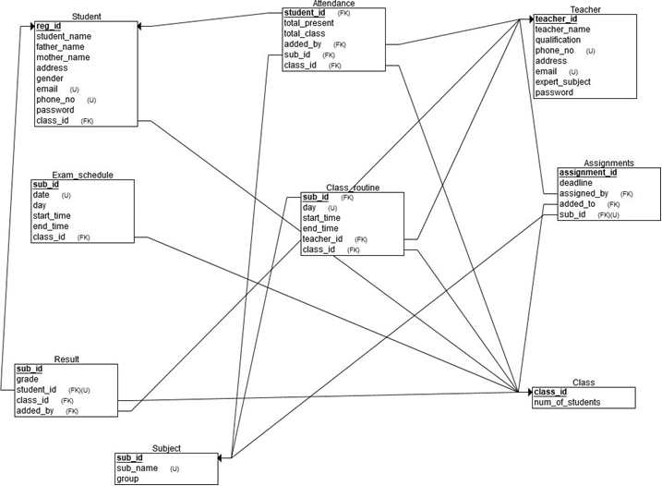

Figure 6:1Schema diagram

Entity Relational Diagram:

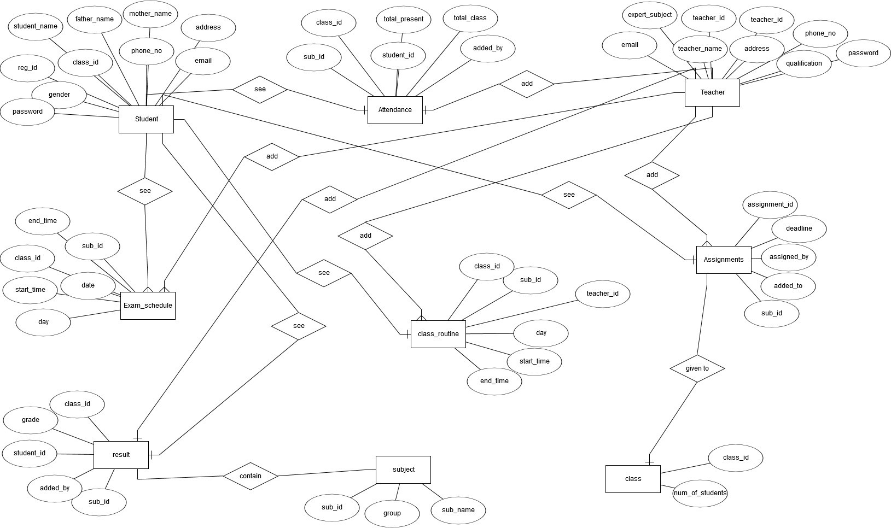

Figure 6:2Entity Relational Diagram

### UML design: Use cases

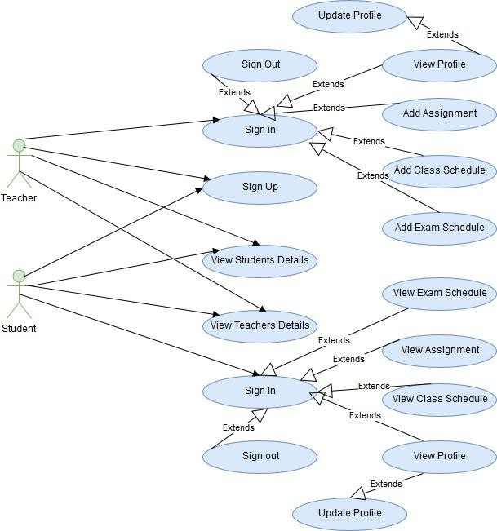

Figure 6:3Use cases

### Activity diagram:

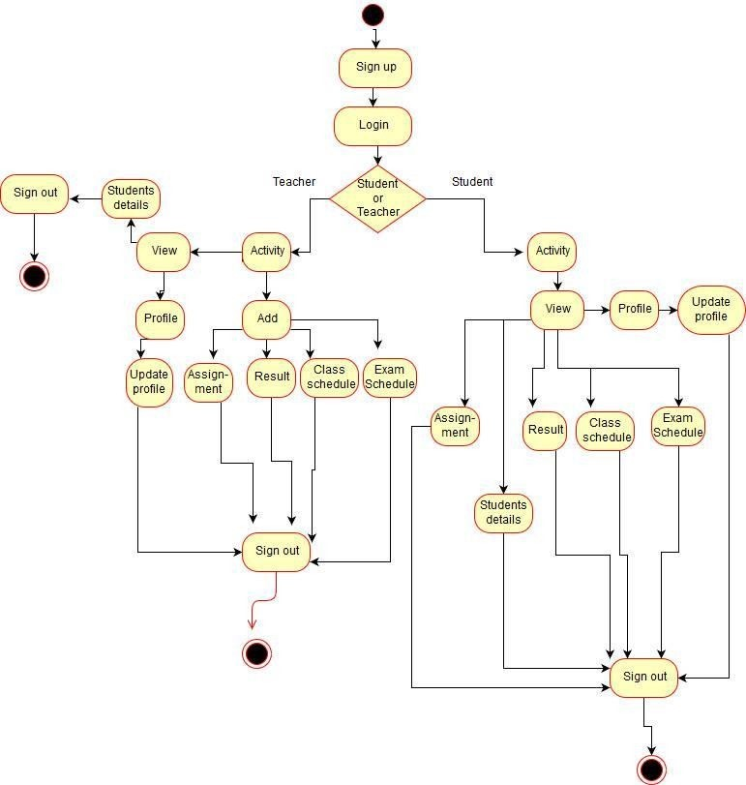

Figure 6:4Activity diagram

# Development process:

We followed waterfall model as the development process. We followed all 6 phases of waterfall model.

# Testing

# Test items: Image, tables, horizontal line, text field, label, option button, hyperlink, submit button, text area, drop down button.

## Features to be tested:

1. Security
2. Usability
3. Update
4. Delete
5. Add
6. Database connectivity
7. Login validation
8. Registration form validation

## Testing technique

### Functionality testing:

1. We verify that there is no dead page.
2. Workflow of system were successfully tested.
3. Validations of each field was checked.
4. We also test the data integrity.

Usability testing: We test the navigation bar and content of each page.

Interface testing: Interface testing was performed to verify the interface and the dataflow from one system to other.

### Security testing:

1. SQL Injection will not affect the system as the passwords are stored after being encrypted.
2. Any kind of add, update and delete operations can be performed by only users who have appropriate permission.

Compatibility testing: Browser compatibility were test during testing phase. This application runs on multiple browser such as Mozilla, chrome, explorer etc.

## Testing approach

Unit test: Each component (web pages, classes) of our web application were individually checked multiple times before linking up all the pages.

Integrity test: The interaction between different and separately tested unit were checked after they have been integrated. This step is done until the whole system seemed error free.

### System test: After that we test the complete integrated system

Alpha test: This system was checked by us and other 2-3 friends.

# Limitations

1. Load testing, stress testing and beta testing is not done yet. So the application may fail in real time when many users will use this application concurrently.
2. To use this application internet connection and web browser is needed.

# Improvement Scope

School/College Management: We can extend or convert this project for school/college or any educational institutions.

Parents as user: Parents will act as user so that they can see their children’s academic information via this web site. Such as result, attendance, exam schedule, class routine etc.

Feature: We can also add extra feature according to university requirement.

Performance Report to guardian: University authority can send student’s overall performance report to guardian.

# Graphical User Interface

## Homepage:

Shows some picture and some important information about university.

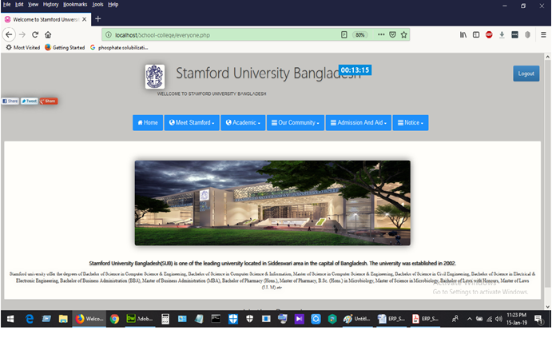

Figure 11:1Homepage

Sign in: User can sign in using email and password.

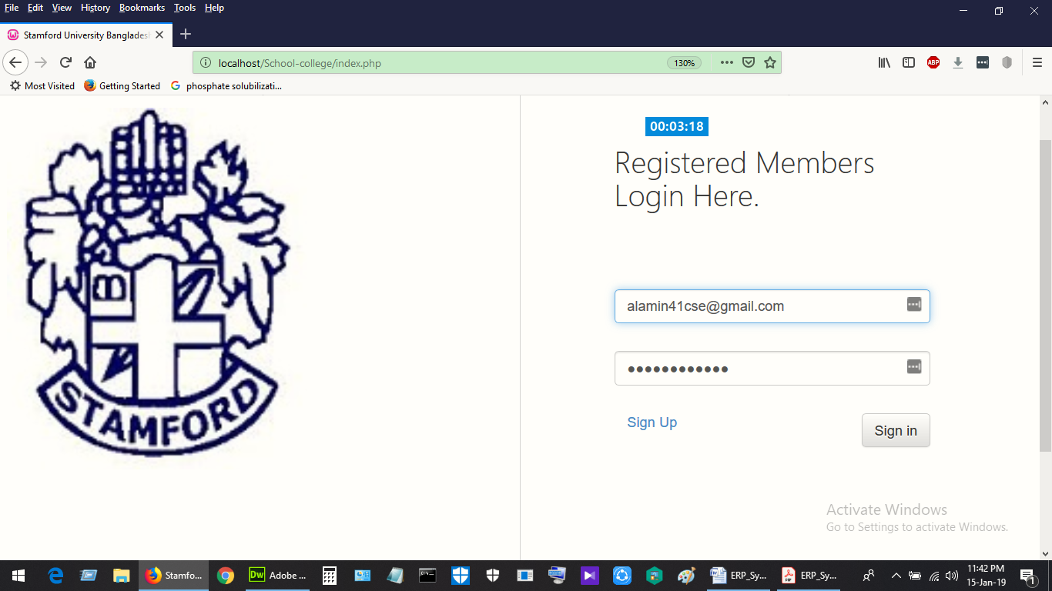

Figure 11:2SignIn

Sign Up: Student and teacher can sign up using their information.

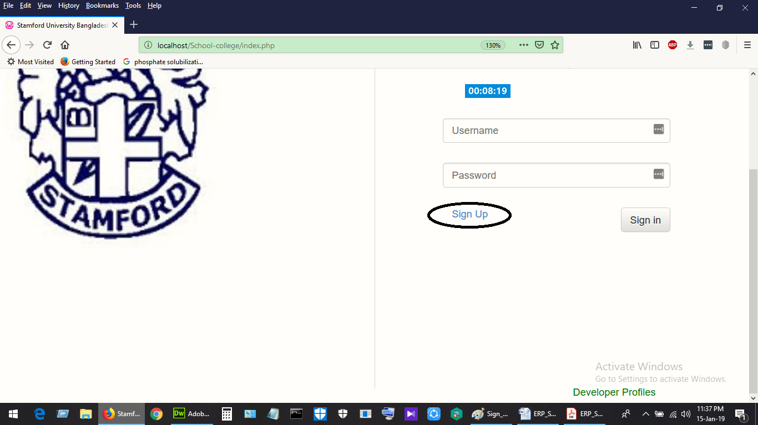

Figure 11:3SignUP

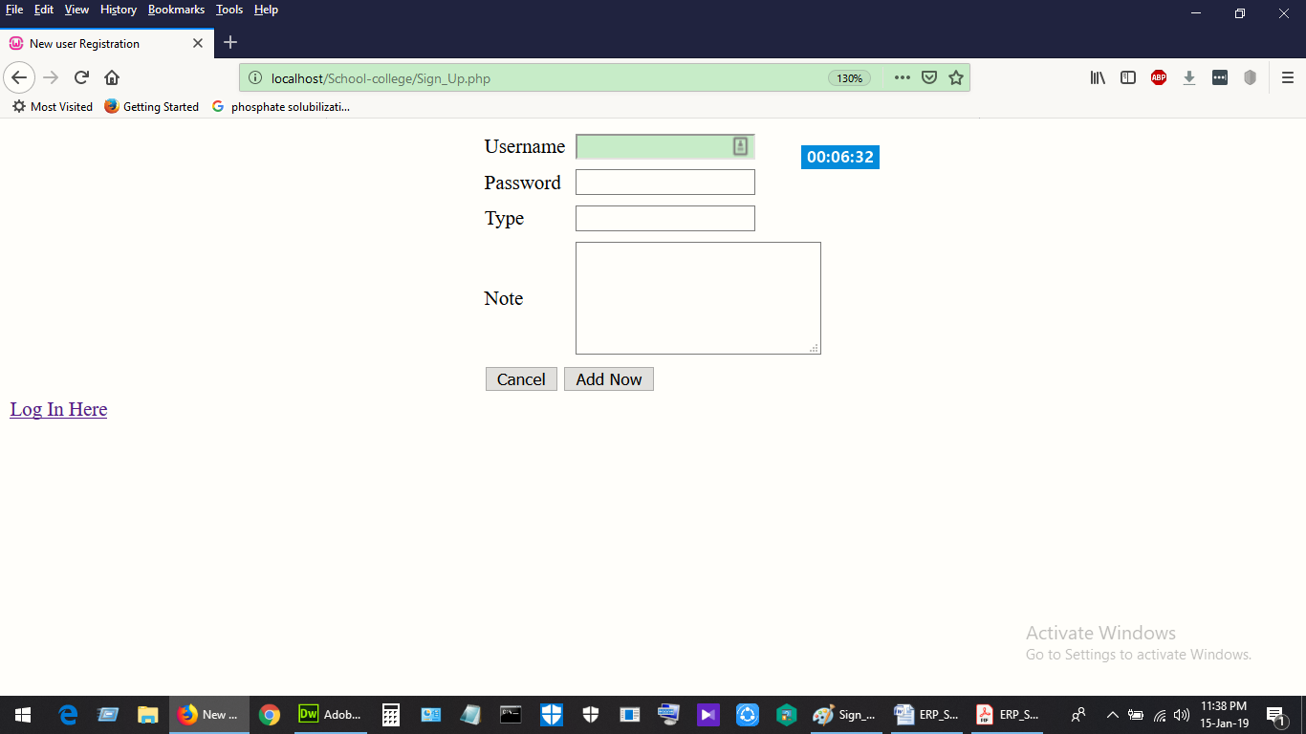

Figure 11:4Sign up as student or teacher

## Add User:

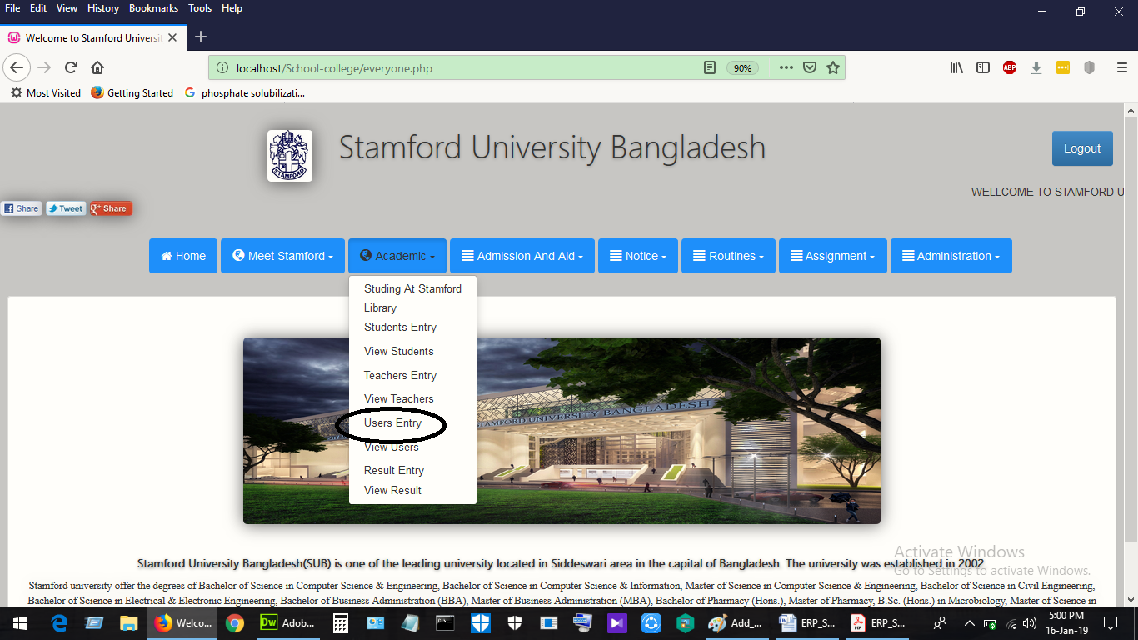

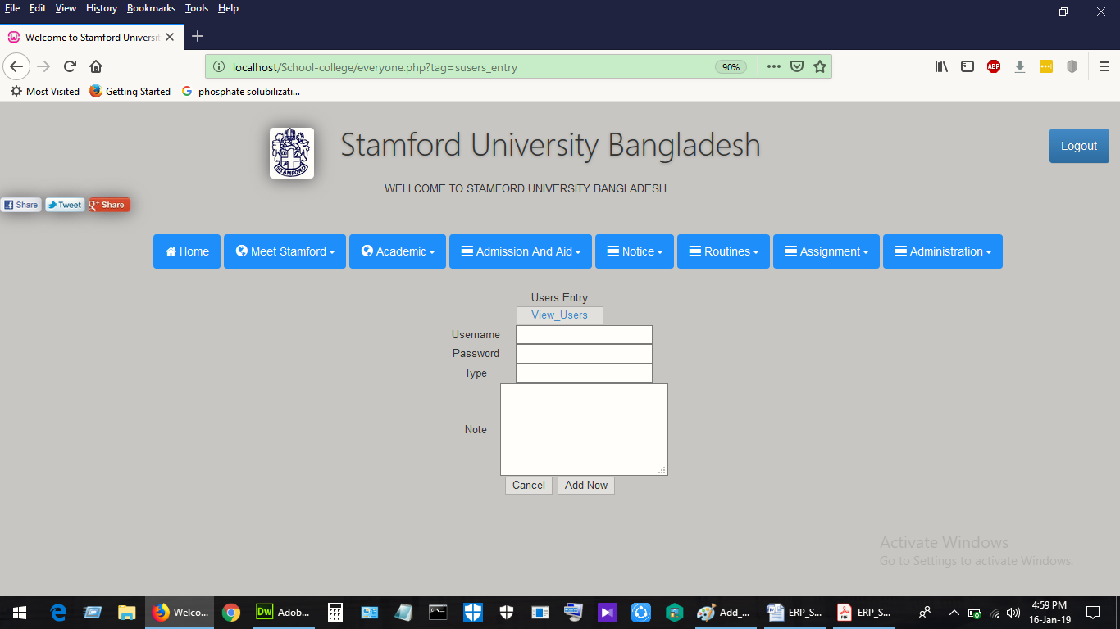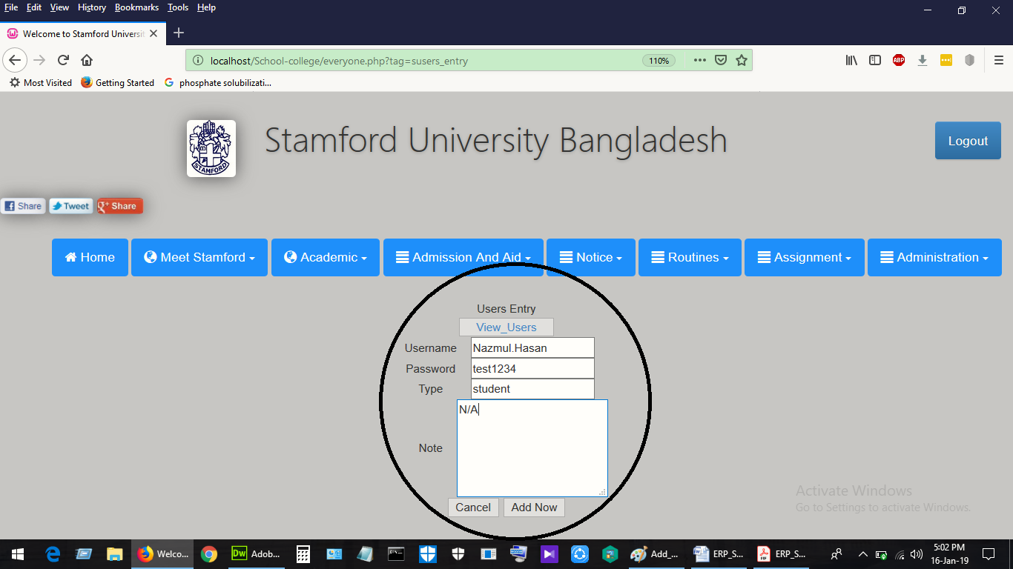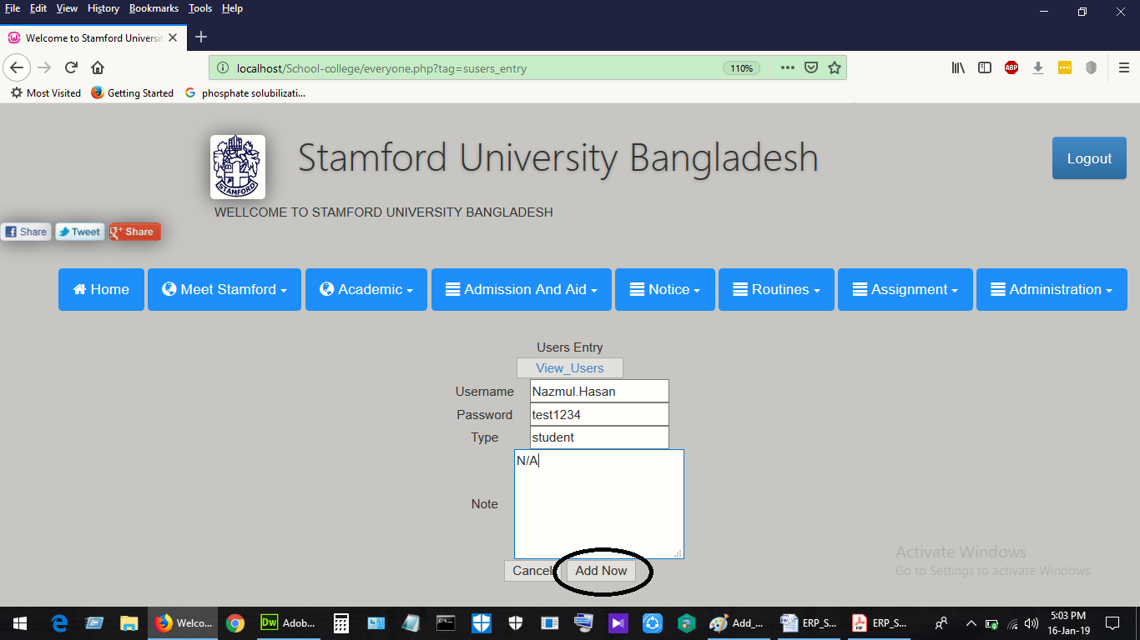

Figure 11:5Add User

## View User:

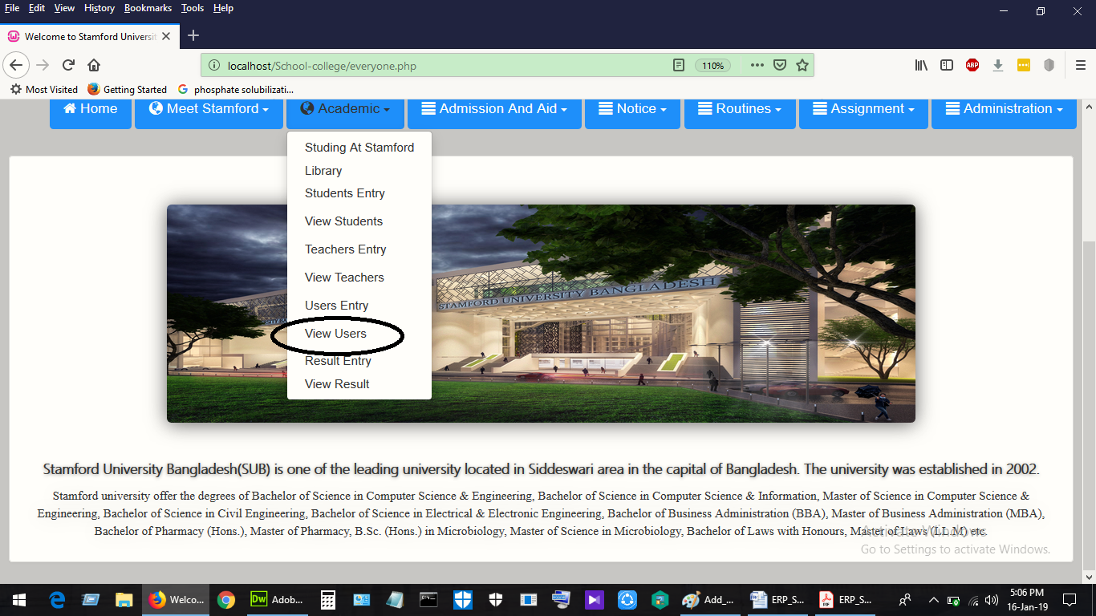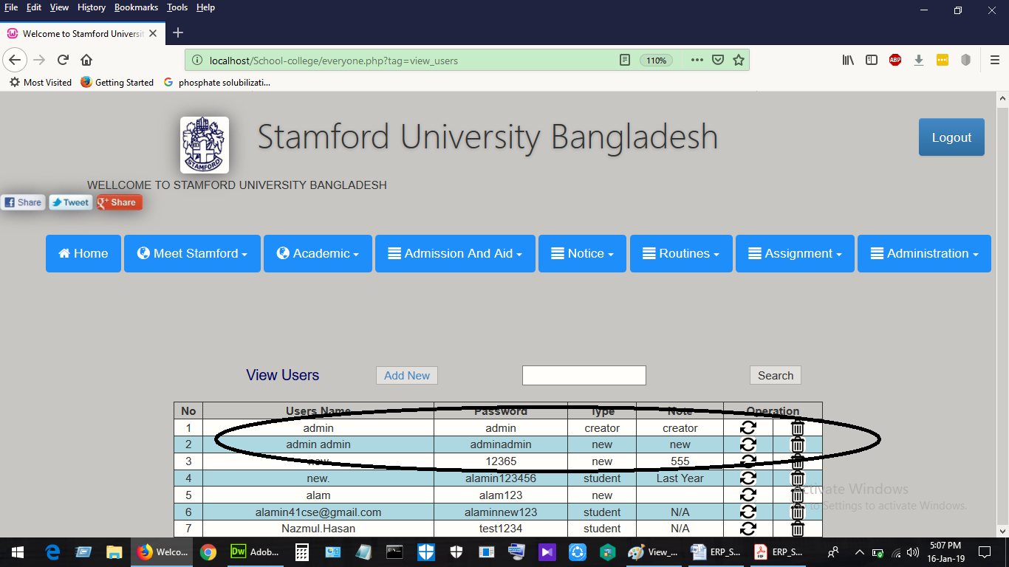

Figure 11:6View User

## Add Students:



Figure 11:7Add Students

## View Students:



Figure 11:8View Students

## Add New User:

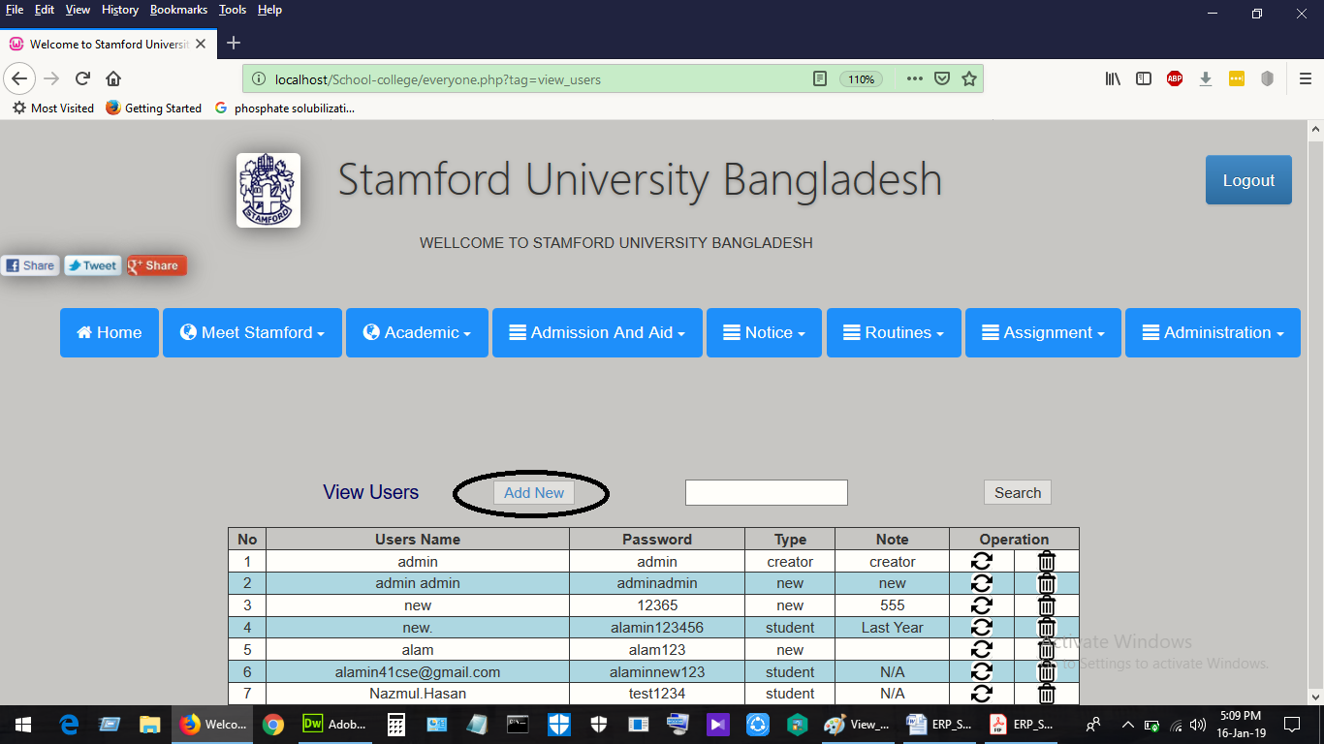

Figure 11:9Add New User

## Search User:

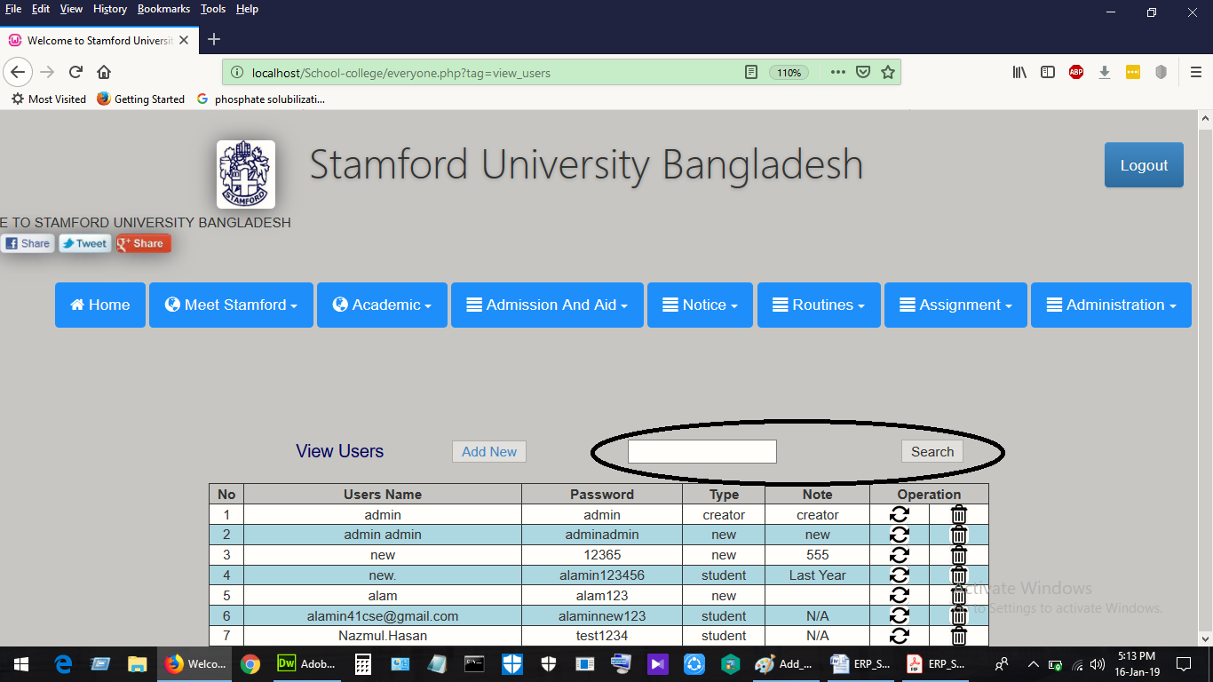

Figure 11:10Search and user

## Update User:

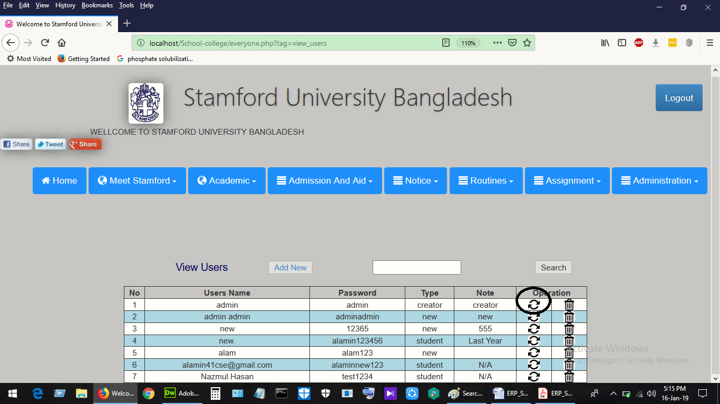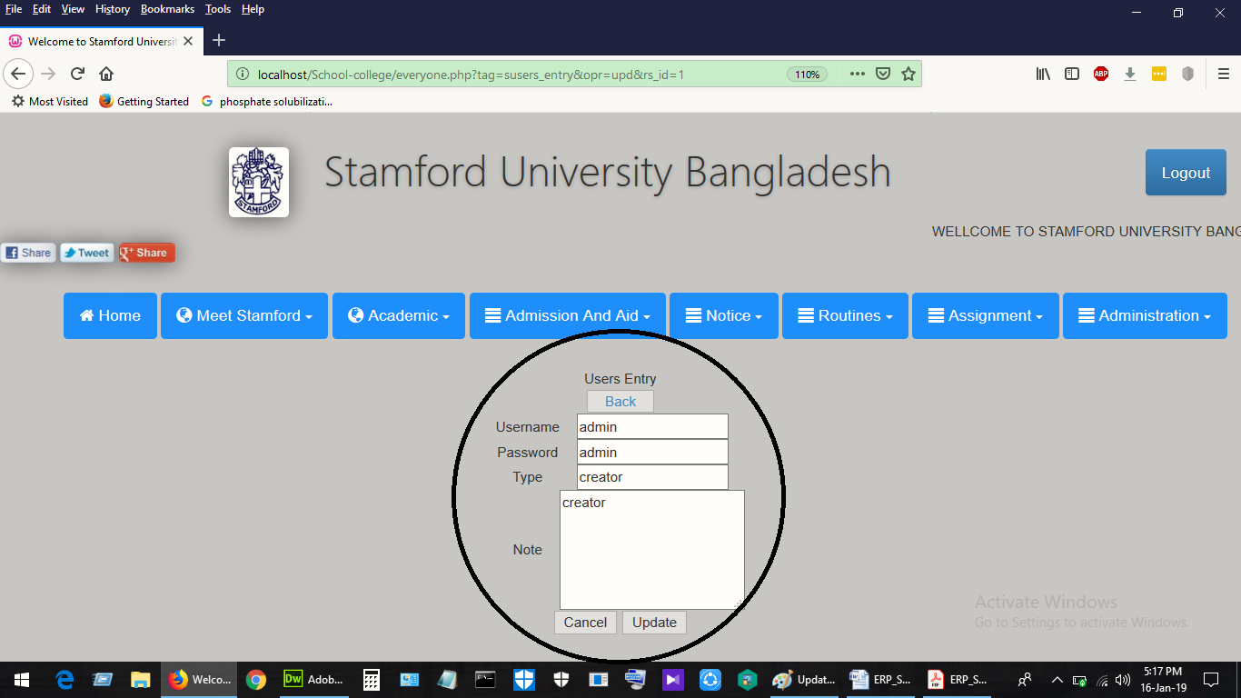

Figure 11:11Update User

## Delete User:

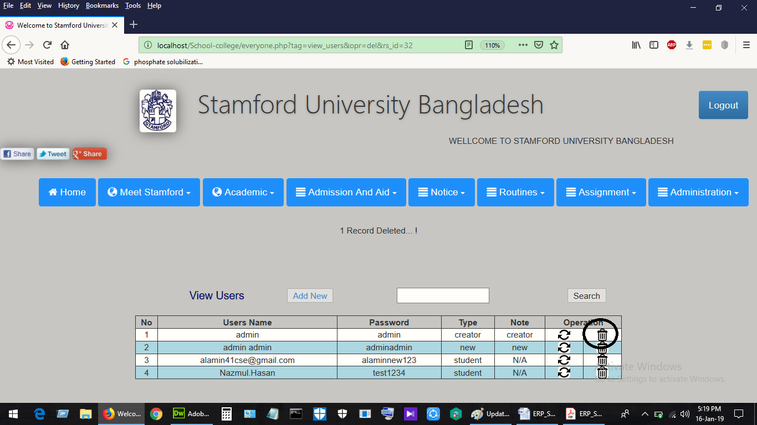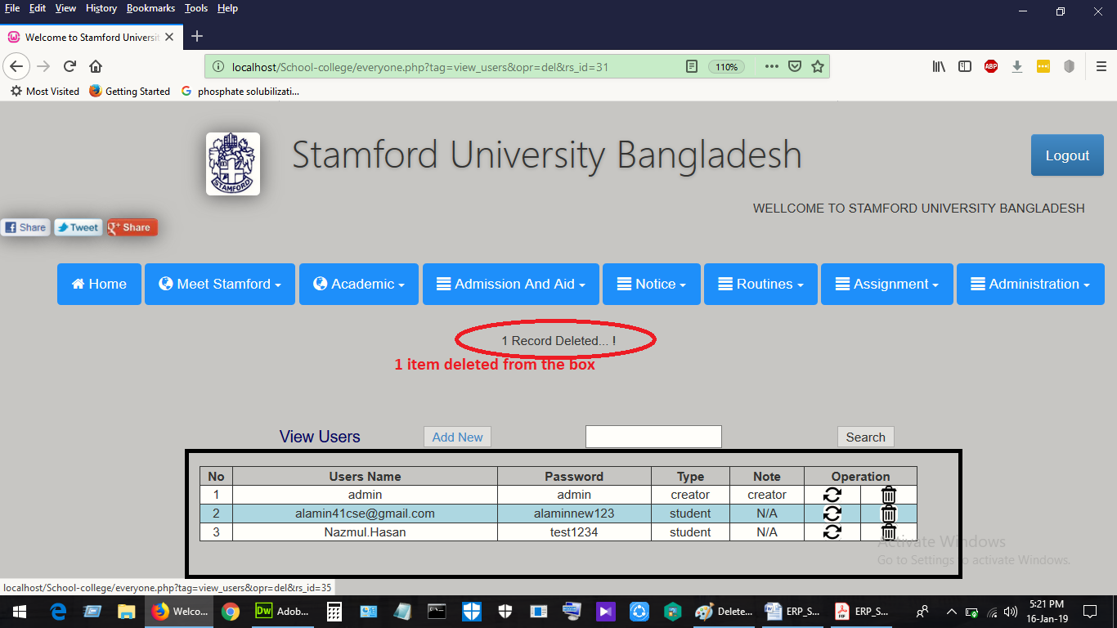

Figure 11:12Delete user

## Add Result:

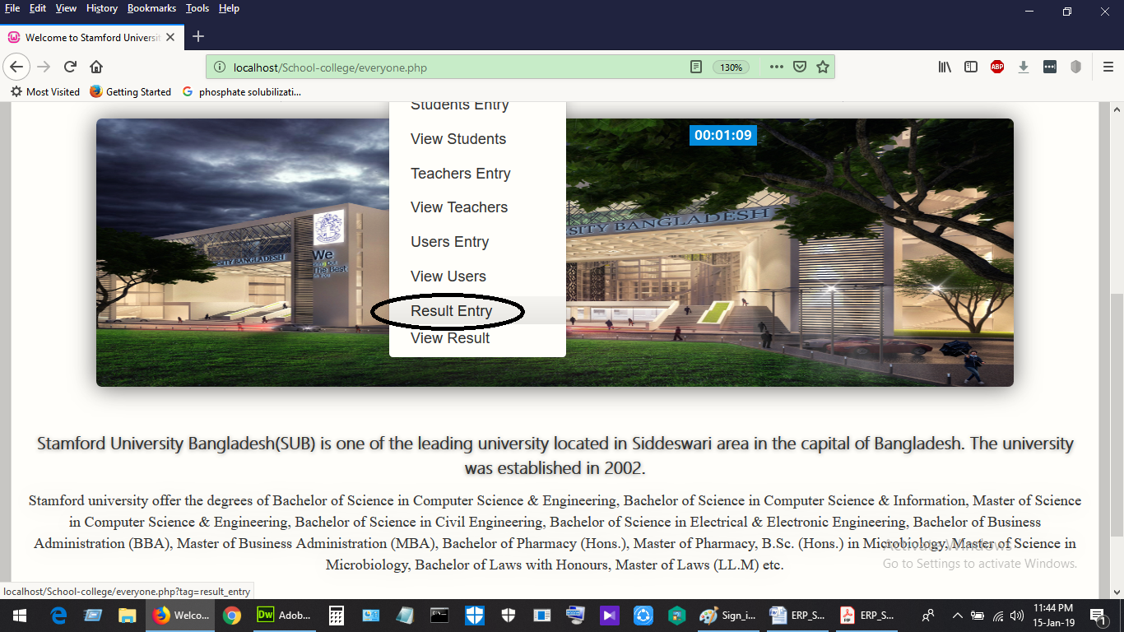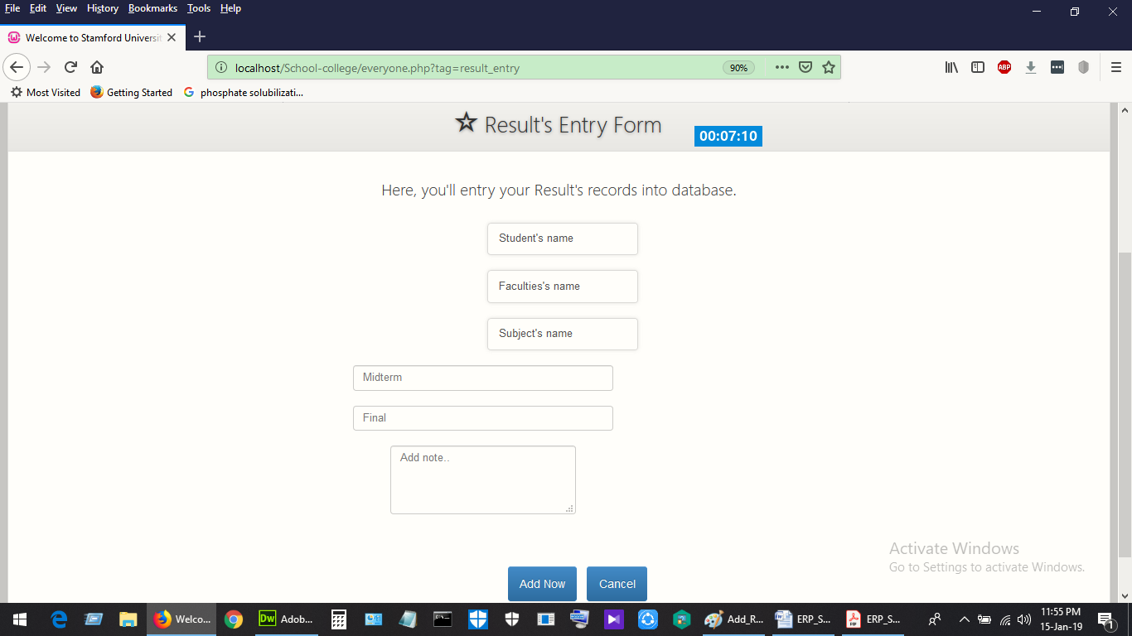

Figure 11:13Add Result

## Show Result:

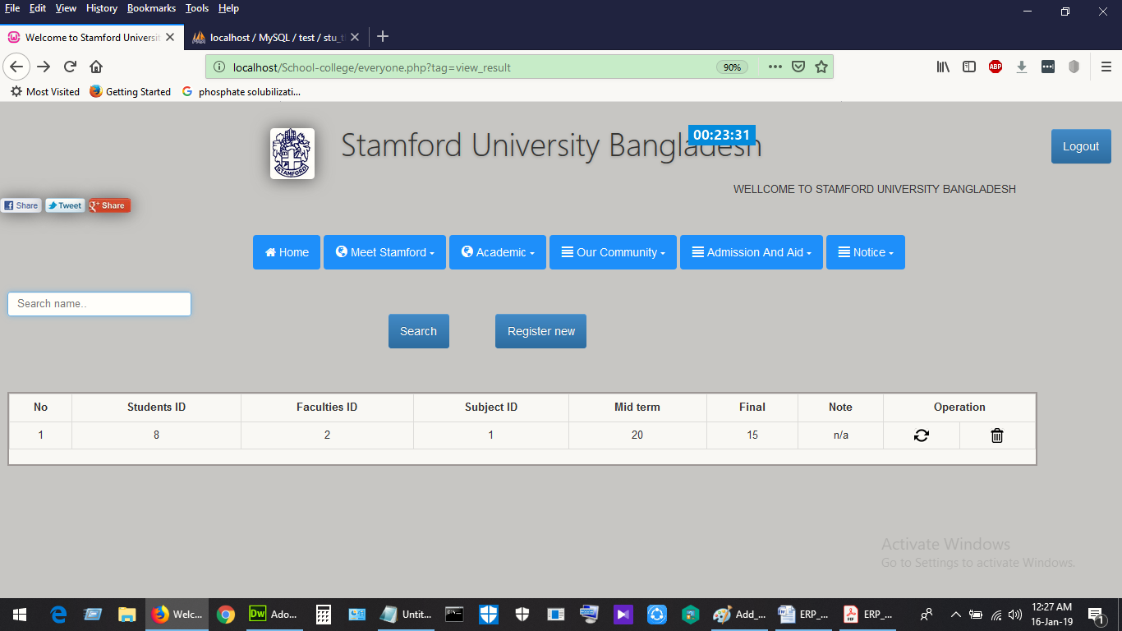

Figure 11:14Show result

## Add Notice:

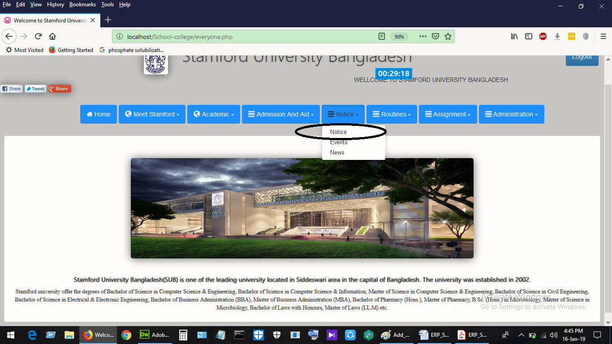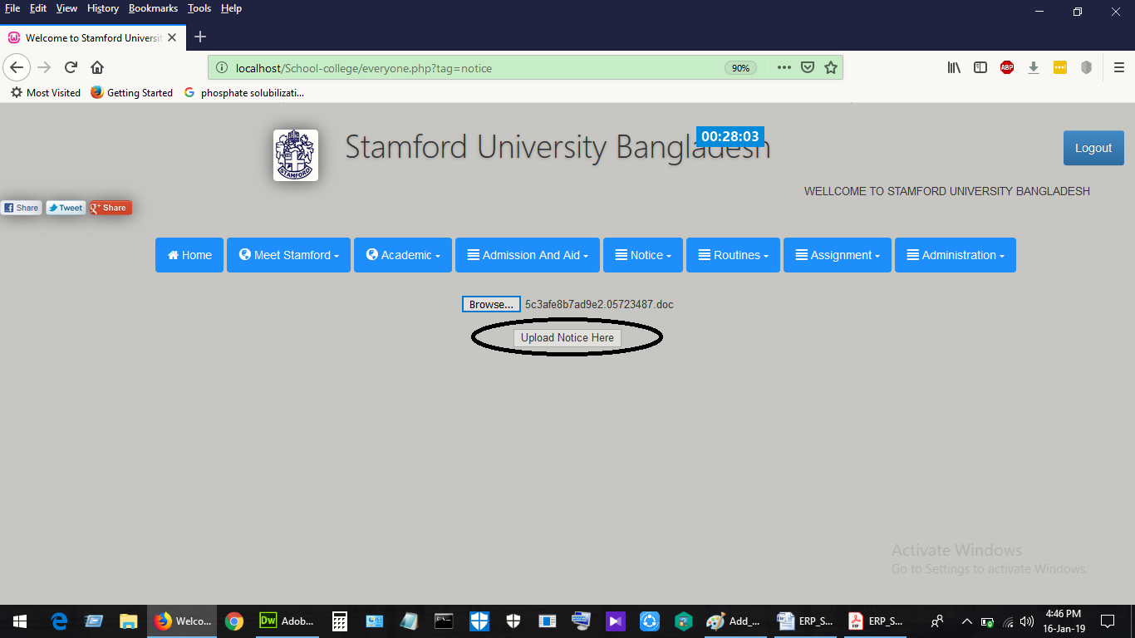

Figure 11:15Add Notice

## Add Events:

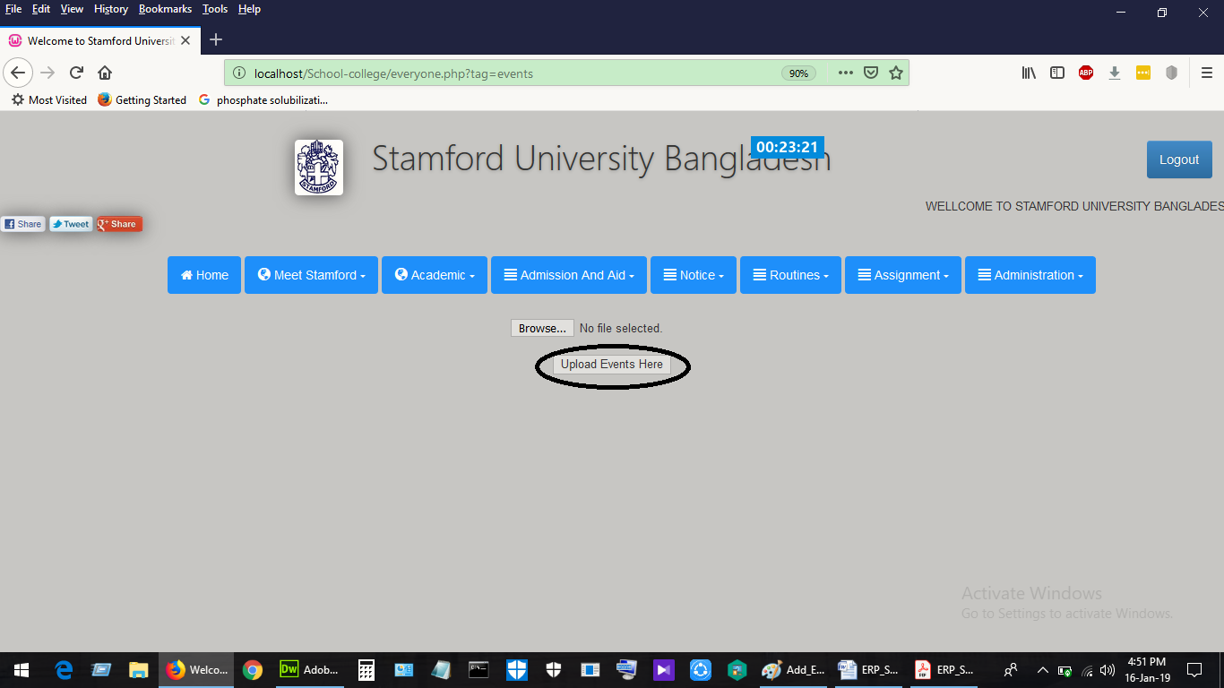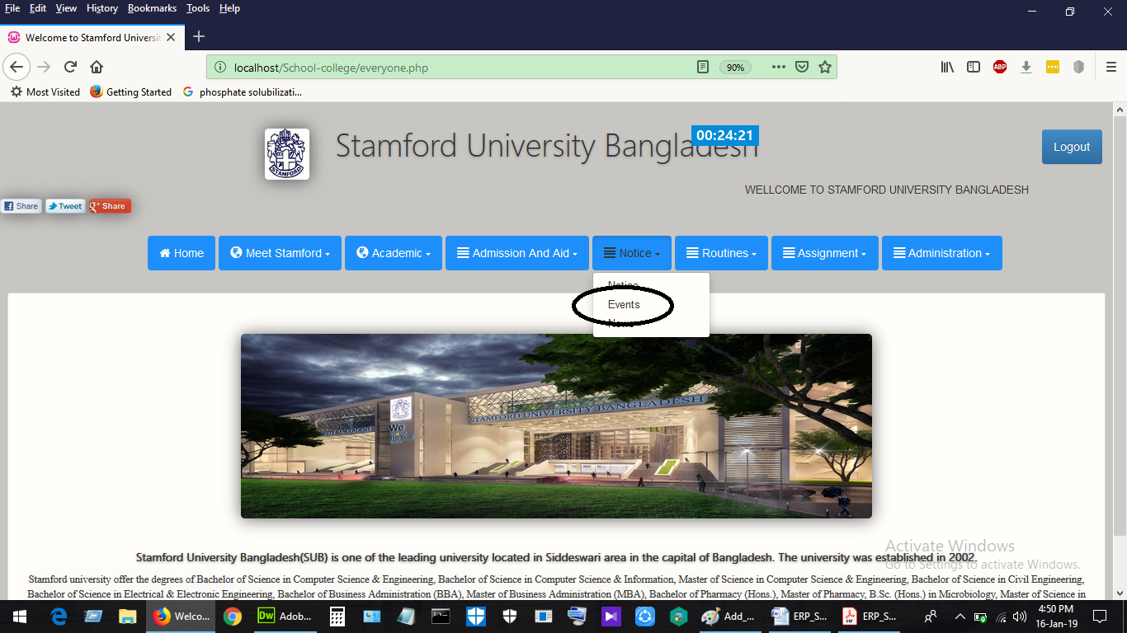

Figure 11:16Add Events

## Add News:

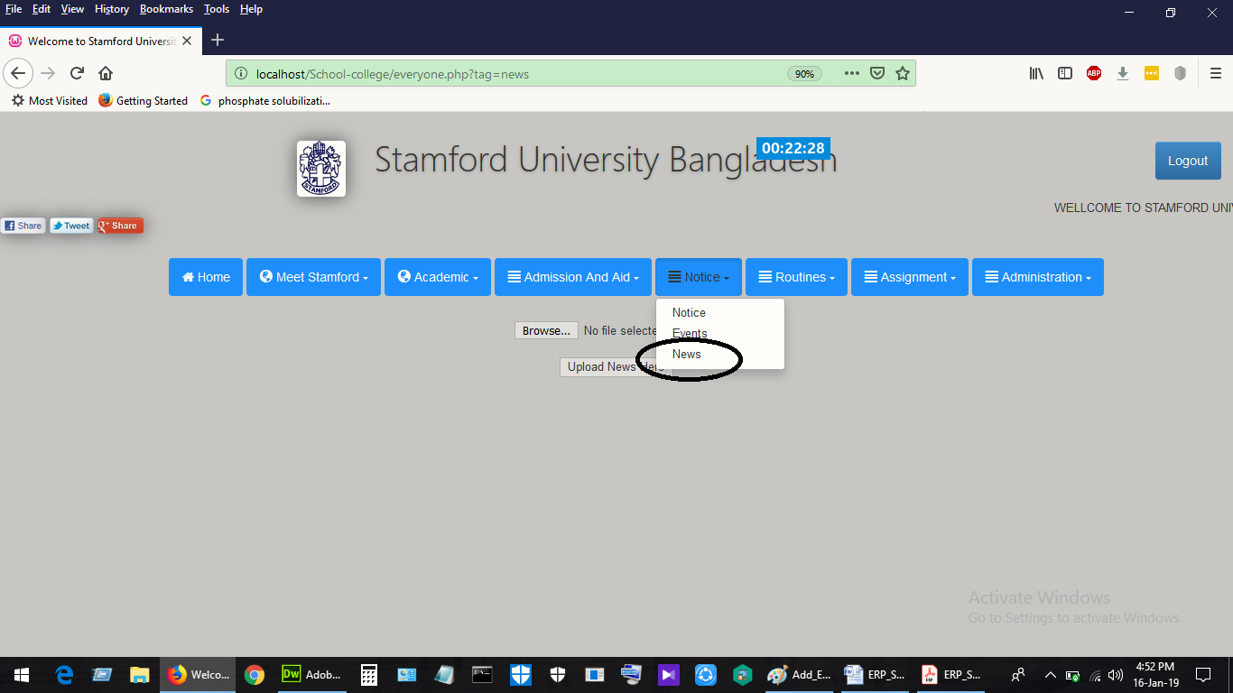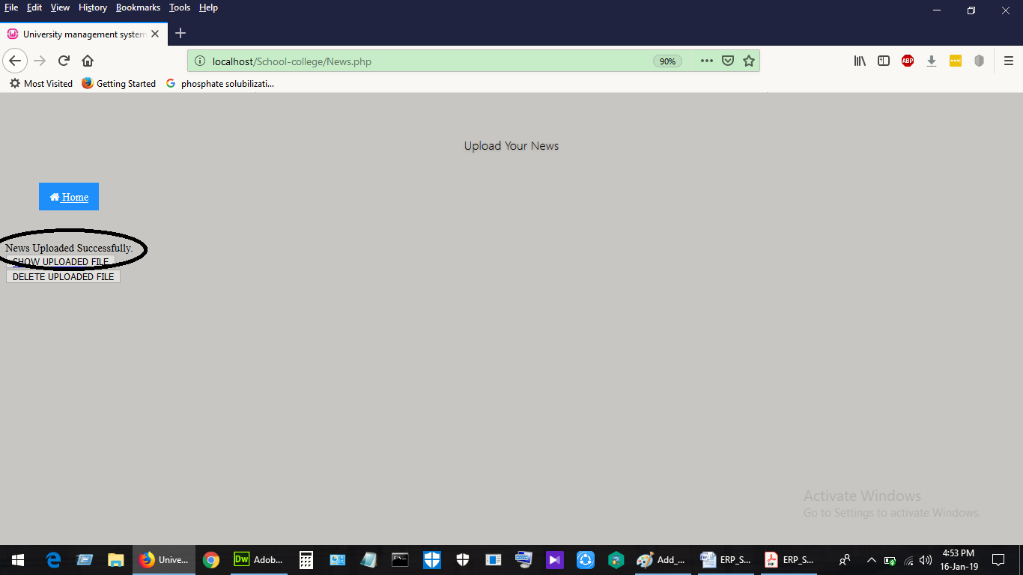

Figure 11:17Add News

Add Class Routine: Teacher can add routine.

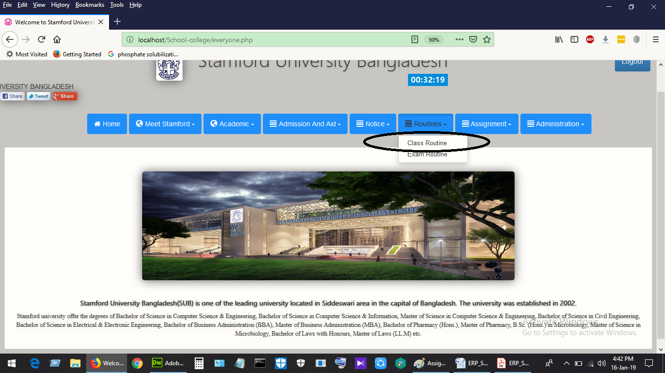

Figure 11:18Add Routine

Add Exam Routine: Teacher can add exam routine by selecting class, pdf file and group.

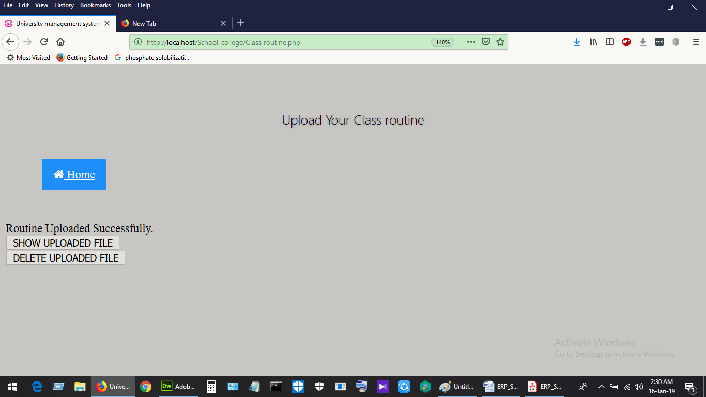

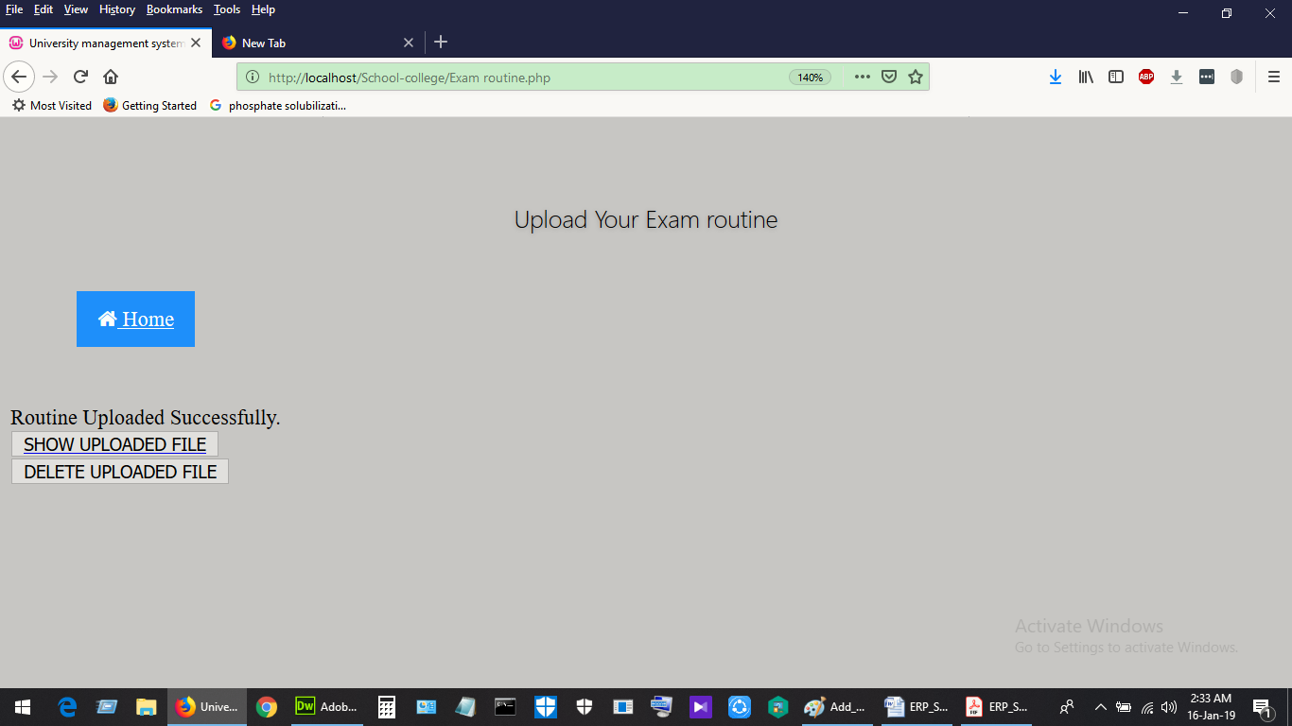

Figure 11:19Add Exam Routine

Add Assignment: Teacher can add assignment with topic name, deadline and other information.

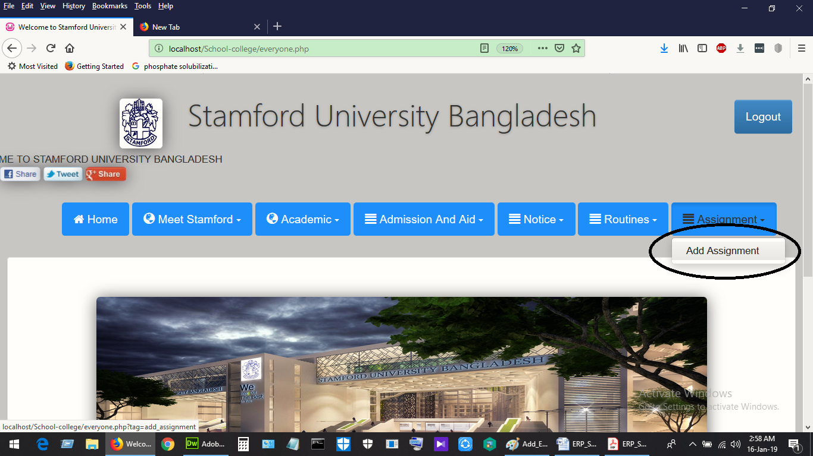

Figure 11:20Add Assignment

### Profile: Developer Profile:

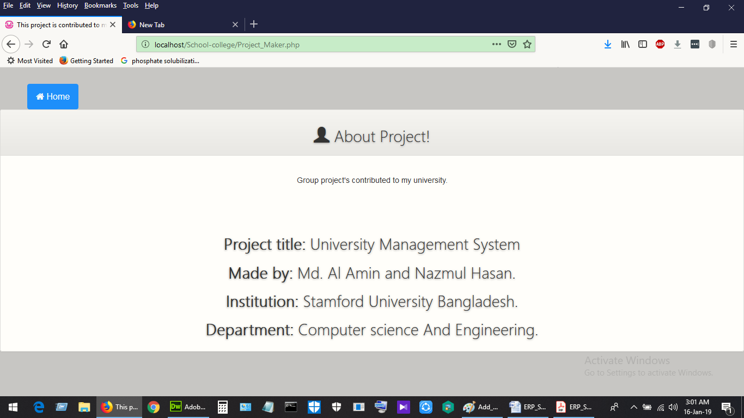

Figure 11:21Developer Profile

## Admin:

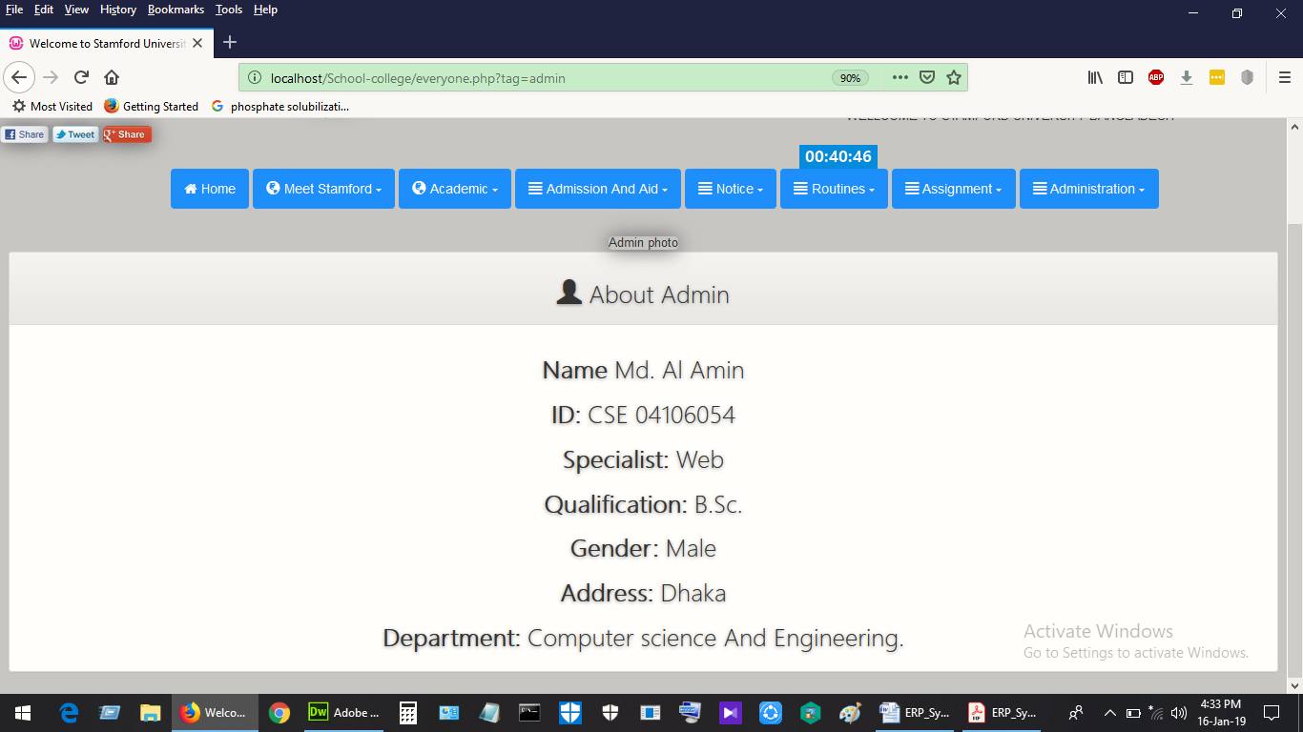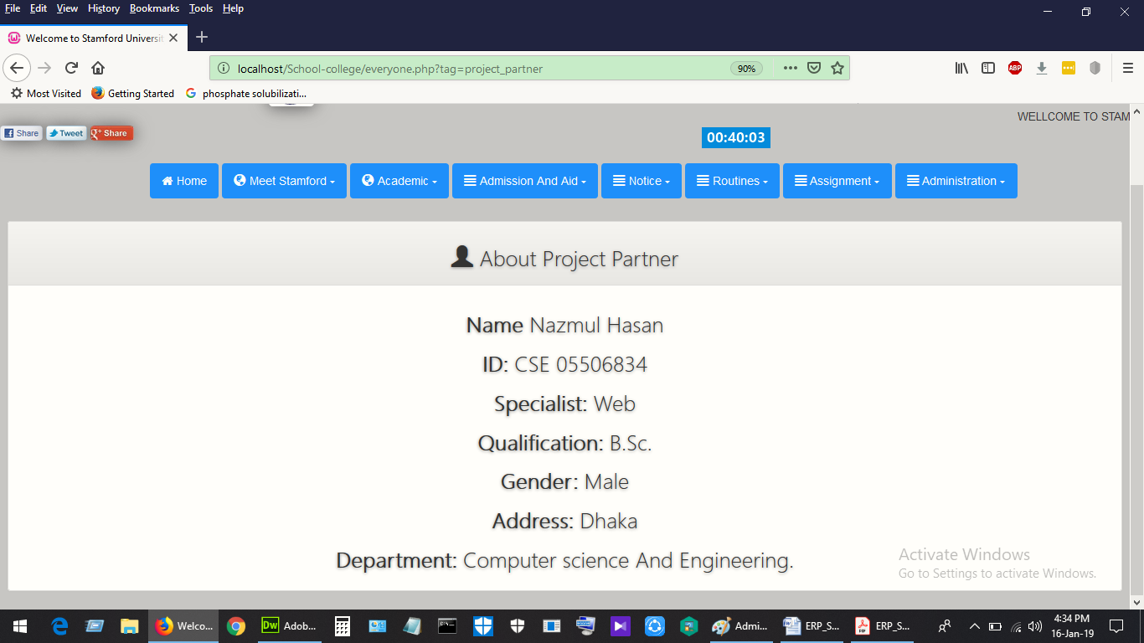

Figure 11:22Admin Page

# Reference

[1]S. Barun Kanti Das, "Stamford University Bangladesh", *Stamforduniversity.edu.bd*, 2019. [Online]. Available: http://www.stamforduniversity.edu.bd/. [Accessed: 16- Jan- 2019].

[2]Princeton University. (2019). *Princeton University*. [online] Available at: https://www.princeton.edu/ [Accessed 16 Jan. 2019].

[3]2019. [Online]. Available: https://www.sust.edu/. [Accessed: 10- Jan- 2019].

[4]U. Rajshahi, "Rajshahi University – Official Website of Rajshahi University", *Ru.ac.bd*, 2019. [Online]. Available: http://www.ru.ac.bd/. [Accessed: 02- Jan- 2019].

[5]"Bangladesh Agricultural University| Home", *Bau.edu.bd*, 2019. [Online]. Available: https://www.bau.edu.bd/. [Accessed: 03- Jan- 2019].

[6]2019. [Online]. Available: http://www.rtu.ac.in/. [Accessed: 15- Nov- 2019].